**Deployment of Serverless Application on AWS**

**Table of Contents**

1. Introduction
2. Architecture Overview
3. Components and Services

* Amazon S3
* Amazon CloudFront
* Amazon Route 53
* AWS Lambda
* Amazon DynamoDB

1. Deployment Process
2. Security and Best Practices
3. Cost Management
4. Conclusion

Project Description: -   
In this Project, we will build a serverless web application using AWS Lambda, DynamoDB and S3. The application will allow users to create, read, update, and delete (CRUD) items from Dynamo DB table.

1. **Introduction**

This document provides a detailed overview of deploying a serverless web application using AWS services. It aims to outline the architecture, components, deployment process, security considerations, and cost management strategies.

1. **Architecture Overview**

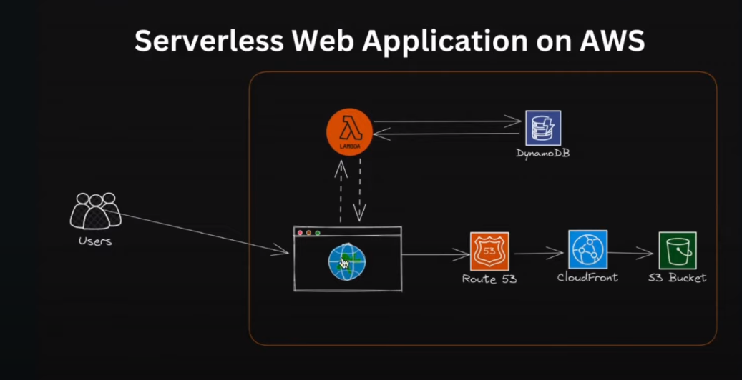

The serverless web application leverages various AWS services to ensure scalability, high availability, and cost efficiency.

The architecture consists of the following key components:

* **Users**: End users who interact with the web application.
* **S3 Bucket**: Stores static assets (HTML, CSS, JavaScript).
* **CloudFront**: Distributes content globally with low latency.
* **Route** **53**: DNS service to route user requests.
* **Lambda**: Executes backend code without provisioning servers.
* **DynamoDB**: NoSQL database for storing application data.

1. **Components and Services**

**Amazon S3**

Amazon Simple Storage Service (S3) is used to store static website content, such as HTML, CSS, and JavaScript files. S3 provides high durability, availability, and scalability for static content.

**Setup Steps:**

**Create an S3 bucket.**

Click on Create Bucket.

**Upload static files to the bucket.**

Click on Upload.

**Configure the bucket to host a static website.**

**S3 bucket 🡪 properties.**

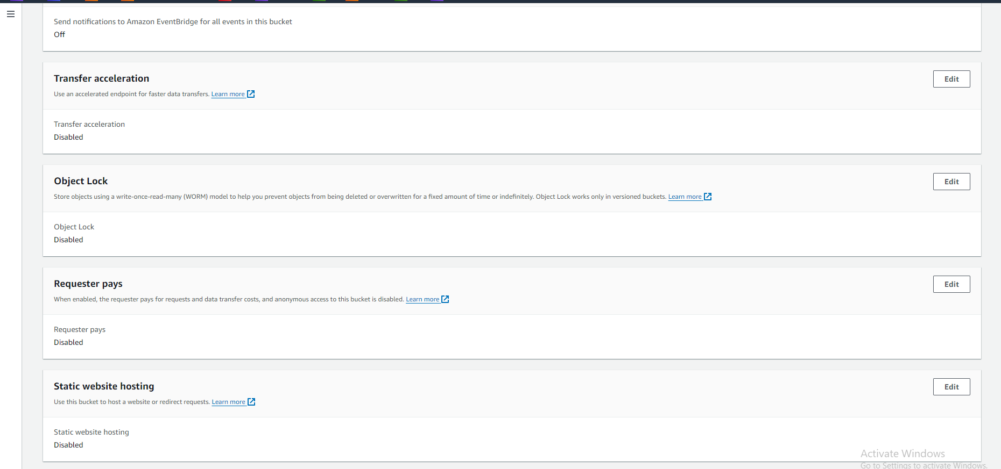

**Edit and enable static website hosting.**

**Amazon CloudFront**

Amazon CloudFront is a content delivery network (CDN) that caches content at edge locations to reduce latency and improve load times for users.

**Setup Steps:**

**Create a CloudFront distribution🡪Specify the S3 bucket as the origin.**  
  
Create a new OAC

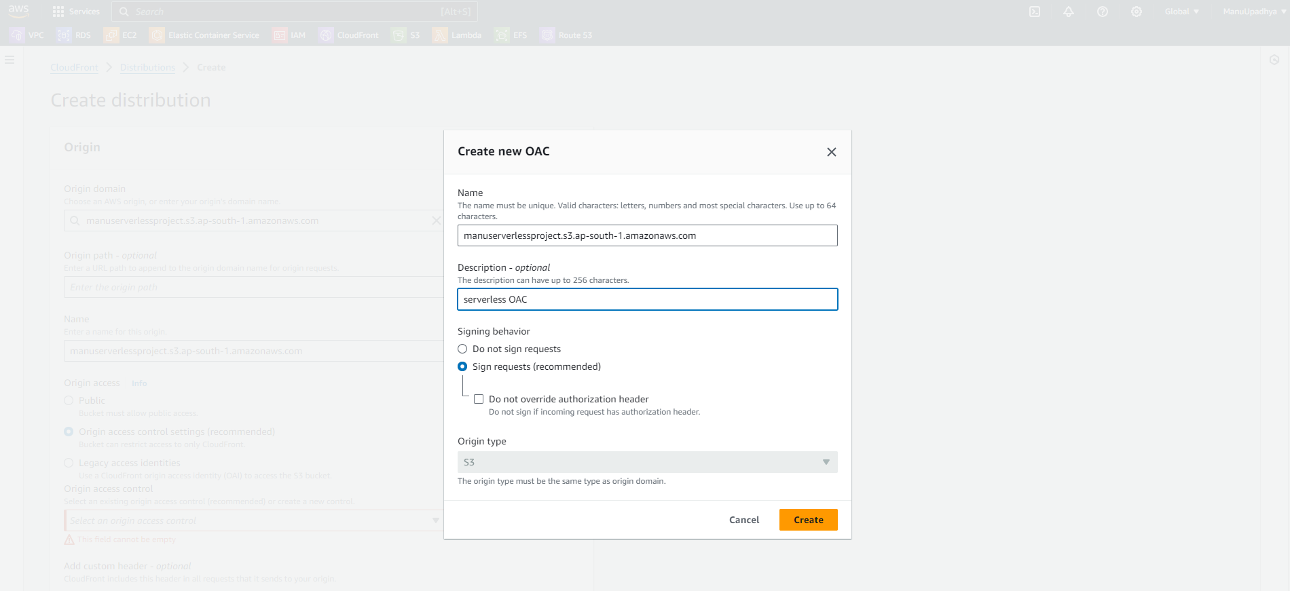  
  
Click on create, select the created OAC.

Leave everything default and click on create Distribution.

**Configure caching policies and distribution settings.**

Get inside the distribution🡪 origins🡪Select the created origin, click on edit.

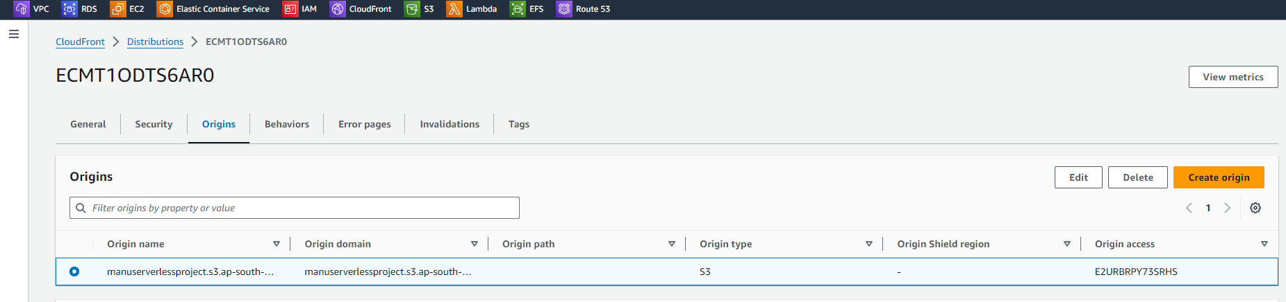

Click on copy policy. We need to paste this in our Amazon S3 bucket.

Created S3 bucket 🡪 Permissions 🡪 Edit bucket Policy and Paste the copied Policy.

Save changes. Adding Policies is Completed.

In CloudFront Distribution settings set root object as **index**.**html**

**Amazon Route 53**

Amazon Route 53 is a scalable DNS and domain name registration service. It routes user requests to the CloudFront distribution.

**Setup Steps:**

**Register a domain or use an existing domain.**

I already have a domain name so I will be using the same domain.

**Create a hosted zone for the domain.**

I already have a hosted zone created previously I will be using the same.

**Configure DNS records to point to the CloudFront distribution.**

Navigate to CloudFront🡪edit settings,

Click on add item. And give the domain name.

Request SSL Certificate.

Create a SSL Certificate using Amazon Certificate Manager.

It will take some time to get certificate.

We need to validate the certificate by creating a DNS Record.

Go inside certificate,

Click on create a record in Route53.

Now status changed to issued.

Select the certificate in cloud front distribution page.

Click on Save changes.

We need to create a record for our domain that is for (**greetings**.manojupadhya.in) Navigate to Route 53 to create Record.

Add greeting.manojupadhya.in to direct to CloudFront distribution.

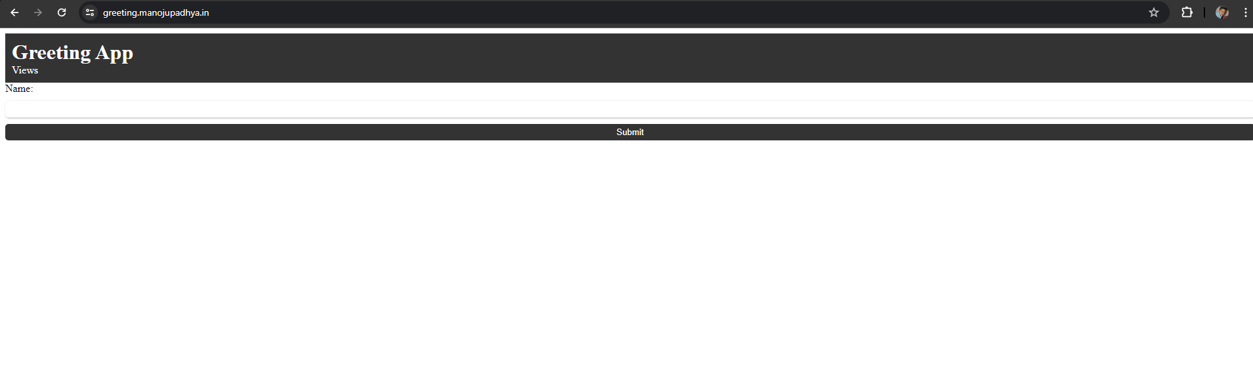

Amazon DynamoDB

Amazon DynamoDB is a fully managed NoSQL database service that provides fast and predictable performance with seamless scalability.

**Setup Steps:**

**Create a DynamoDB table to store application data.**

Navigate to DynamoDB from management console.

Click on the create table.

Rest are default click on create.

Now navigate inside the table🡪Actions🡪 Create Item.

**Now we will create an IAM Role with access to Lambda functions.**

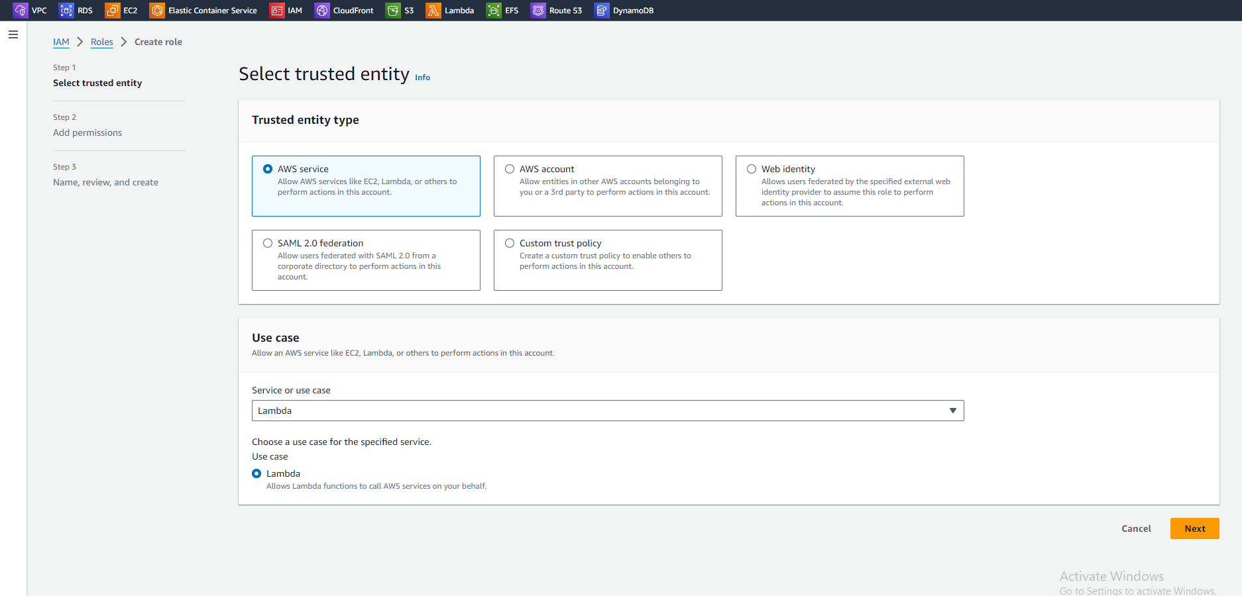  
next

Created role.

**AWS Lambda**

AWS Lambda allows running code without provisioning or managing servers. It executes backend logic in response to events, such as HTTP requests.

**Setup Steps:**

**Write and test Lambda functions. Integrate Lambda functions with DynamoDB to perform view operations.**

Navigate to AWS Lambda

Create function

Advanced settings enable function URL.

Attach created IAM role to this function by navigating to configurations🡪Permissions

Select our role which is required for the project.

Adding code for lambda function.

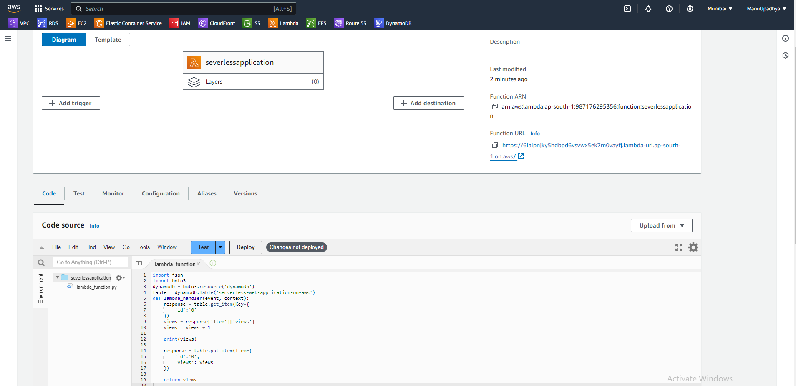

Deploy and test it again.

When test the lambda function view must be incremented as below: -

The updated view count in DynamoDB table.

Code for Lambda function is uploaded, we need function to calculate views or website visits count.  
  
Our work is almost finished…….  
 **Now changes in website code to get view counter to display in web page.**

**Add the lamda function URL in script.js file.**

**Do Not forget to update the code file in S3 bucket, upload these files again….**

**TESTING…….  
  
  
Open the DNS name of the Website…..**